**Worksheet-3.1**

**Student Name:-** Pushpraj Roy **UID:-** 20BCS9866

**Branch:-** BE- CSE **Section/Group:-** WM_617 “A”

**Subjetct Code:-** 20CSP-317 **Semester:-** 5th

**Subject Name:-** Machine Learning Lab

1. **Aim/Overview of the practical:-**

Implement K-means clustering algorithm (cluster some sample data set into disjoint clusters using K-means).

1. **Task to be done/ Which logistics used:-**

Implement K-means clustering algorithm

1. **Steps for experiment/practical/Code:-**

**\*\*Implements K-Mean Clustering on Any Dataset.\*\***

import matplotlib.pyplot as plt

from sklearn.cluster import KMeans

**# **This is the Specific Example for the K-Mean Clustring\*\***

x = [4, 5, 10, 4, 3, 11, 14, 6, 10, 12]

y = [21, 19, 24, 17, 16, 25, 24, 22, 21, 21]

plt.scatter(x,y)

plt.show()

data = list(zip(x,y))

print(data)

inertias = []

for i in range(1,11):

    kmeans =KMeans(n_clusters=1)

    kmeans.fit(data)

    inertias.append(Kmeans.inertia_)

plt.plot(range(1,11), inertias, marker='o')

plt.title('Elbow method')

plt.xlabel('Number of clusters')

plt.ylabel('Inertia')

plt.show()

kmeans = KMeans(n_clusters=2)

kmeans.fit(data)

plt.scatter(x, y, c=kmeans.labels_)

plt.show()

1. **Result/Output/Writing Summary:-**

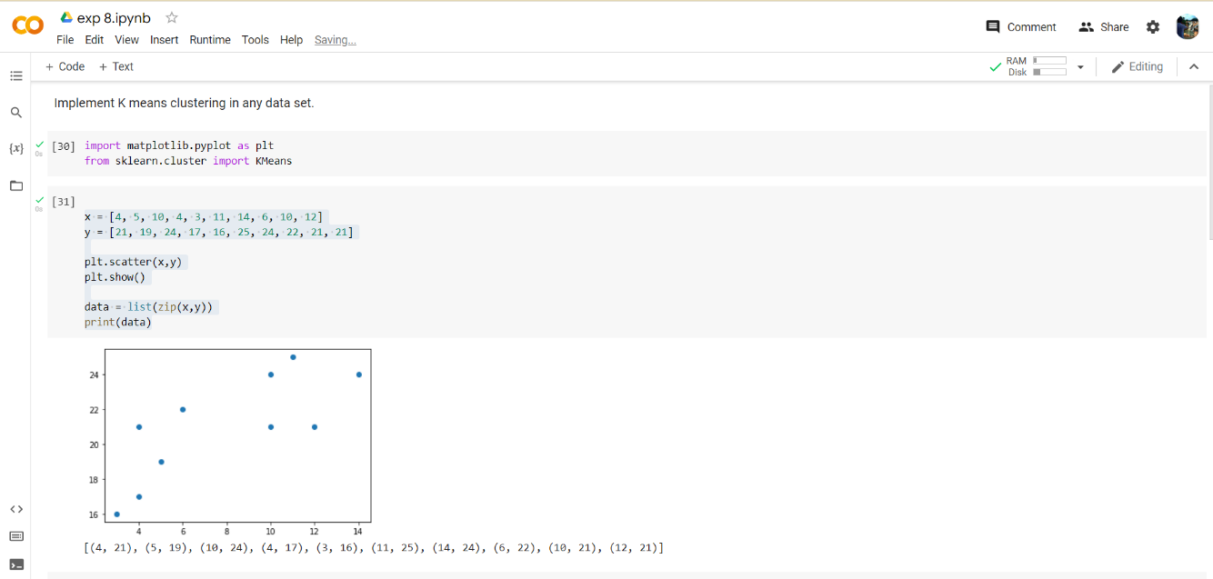

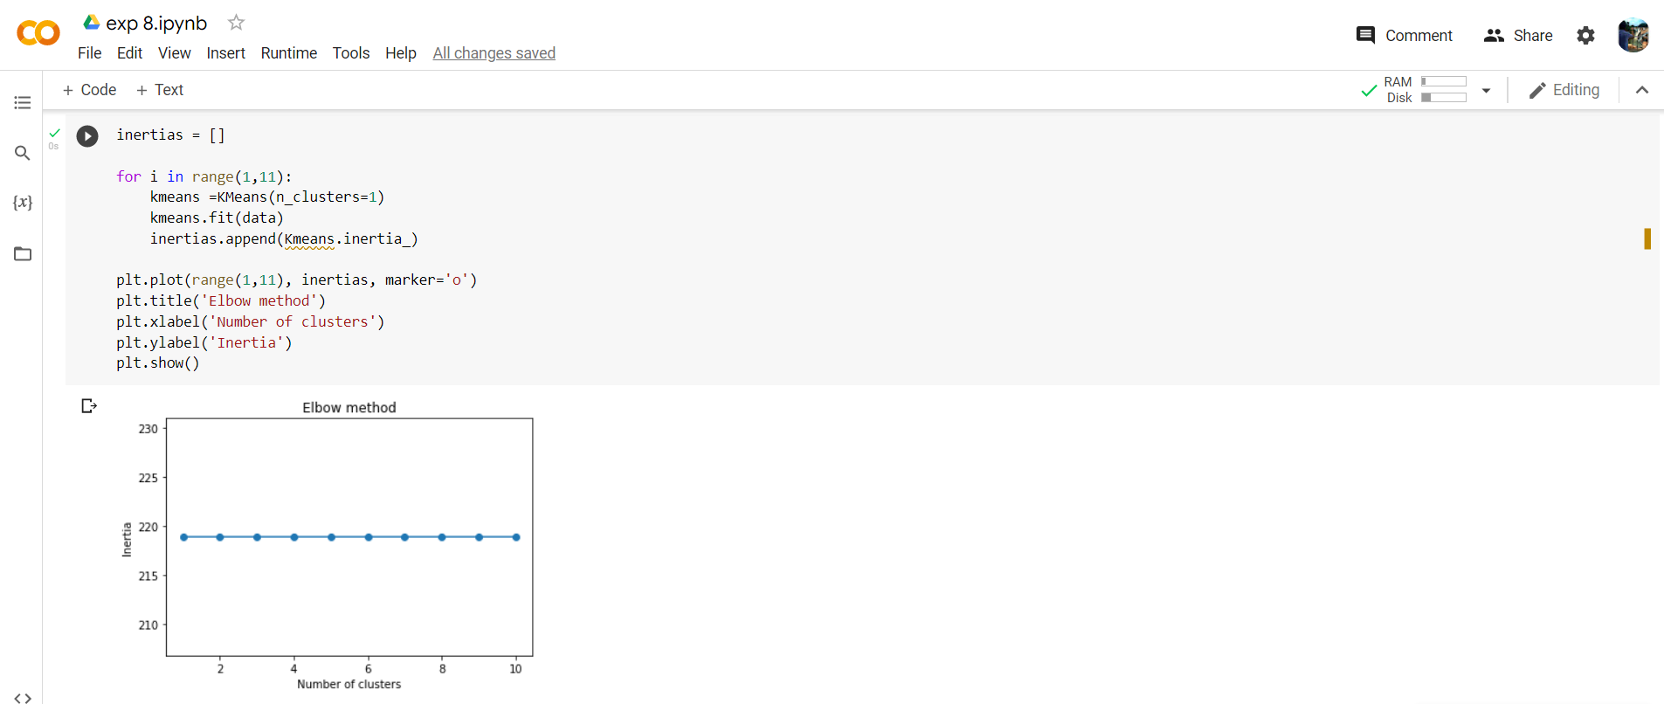

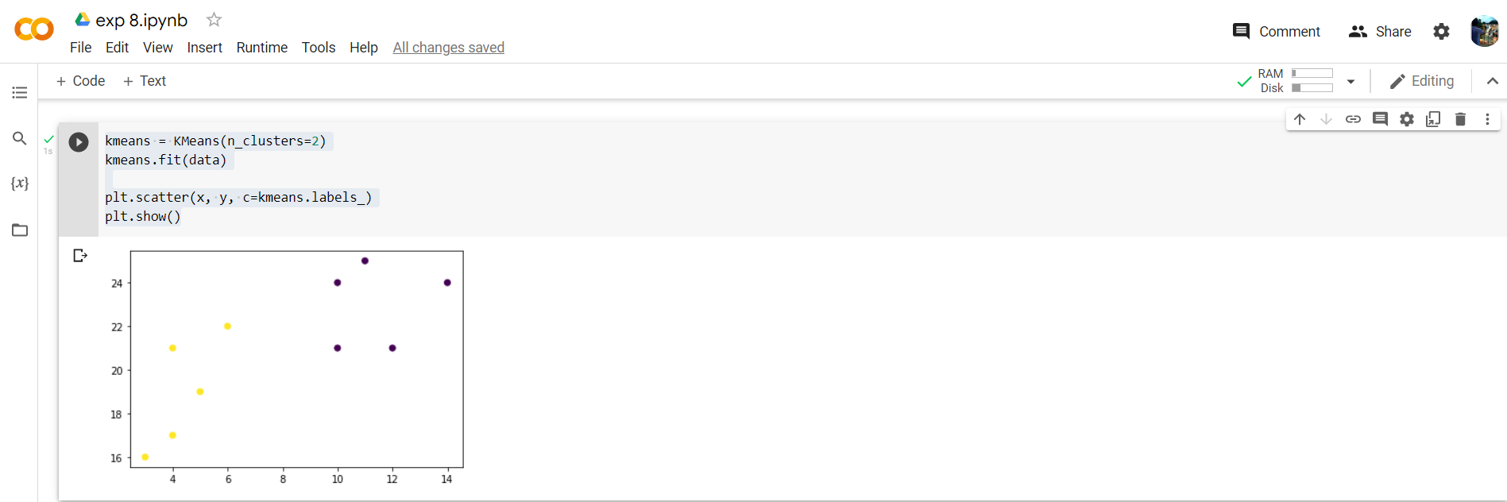

1. **Learning outcomes (What I have learnt):**

* Understood the concept of K-Mean.
* Learnt how to zip the two-array data in a single list.
* Learnt the Inertia calculation.
* Plot the graph for Inertia and Number of clusters.